# Stop Running Elasticsearch. Just Use Postgres.

You want good search. So you’re evaluating Elasticsearch. Or Algolia. Or Typesense. You’re about to spin up another cluster, write data sync pipelines, and add one more thing to your on-call rotation.

**Stop.**

You already have Postgres. And now Postgres has [BM25](https://en.wikipedia.org/wiki/Okapi_BM25).

BM25 (Best Matching 25) is the ranking algorithm behind Elasticsearch, Solr, Lucene, and virtually every production search system. It’s also the retrieval backbone of modern AI: LangChain, LlamaIndex, Cohere Rerank, and most RAG pipelines use BM25 for first-stage retrieval before reranking. When AI search tools like Perplexity or ChatGPT with browsing fetch documents, BM25 is doing the heavy lifting.

CREATE EXTENSION pg_textsearch;  
CREATE INDEX ON articles USING bm25(content);  
  
SELECT * FROM articles   
ORDER BY content <@> to_bm25query('database performance')  
LIMIT 10;

That’s it. Google-quality search ranking. In your existing database. No new infrastructure.

## “But Native Postgres Search Sucks”

You’re right. It does. Let me show you why.

Say you have these documents:

📄 Database Connection Pooling Guide  
 "Database connection pooling improves application performance. A pool   
 maintains reusable connections. Configure pool size based on workload."  
  
📄 Database Fundamentals  
 "Database fundamentals every developer should know. Database design   
 principles. Normalization techniques. Basic indexing strategies."  
  
📄 PostgreSQL Authentication Setup   
 "Set up PostgreSQL database authentication methods. Configure pg_hba.conf   
 for password, certificate, and LDAP authentication. Manage user roles."  
  
📄 Generic Blog Post (spam)  
 "Database database database. Learn about database. Database is important.   
 Database database database. More database info. Database database database."  
  
📄 EXPLAIN ANALYZE Quick Tip (15 words)  
 "Use EXPLAIN ANALYZE to find slow PostgreSQL queries. Shows execution   
 plan and actual timing."  
  
📄 Complete PostgreSQL Query Tuning Guide (80 words)  
 "This comprehensive PostgreSQL guide covers query tuning and optimization.   
 PostgreSQL query performance depends on proper use of EXPLAIN and EXPLAIN   
 ANALYZE. Run EXPLAIN ANALYZE on slow queries. The EXPLAIN output shows the   
 query planner decisions. PostgreSQL indexing improves query speed..."

Now watch what happens with different searches:

### Problem 1: Keyword Stuffing Wins

**Search:** database

| Native Postgres | BM25 |
| --- | --- |
| #1: Generic Blog Post (12 mentions!) | #1: Connection Pooling Guide |
| #2: Connection Pooling Guide | #2: Database Fundamentals |
| #3: Database Fundamentals | #3: Generic Blog Post (pushed down) |

Native counts keywords. More = better. BM25 applies **term frequency saturation**: after a few mentions, additional repetitions barely help. Spam loses.

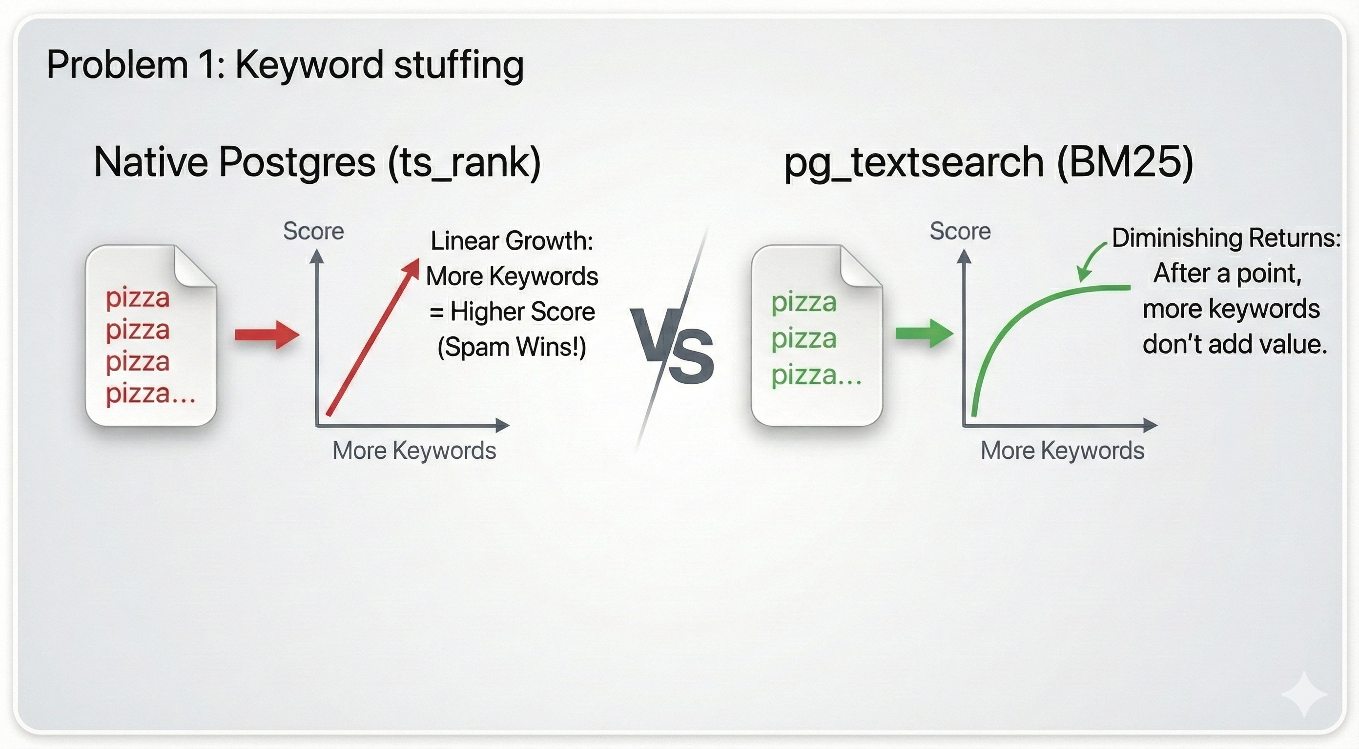

Problem 1: Keyword Stuffing

### Problem 2: Common Words Dominate

**Search:** database authentication

Native treats both words equally. But “database” appears in 10+ docs. It tells you nothing. “Authentication” appears in only 1 doc. That’s the signal.

BM25 uses **Inverse Document Frequency (IDF)**. Rare terms get higher weight. The authentication doc jumps to #1 because “authentication” is the discriminating term.

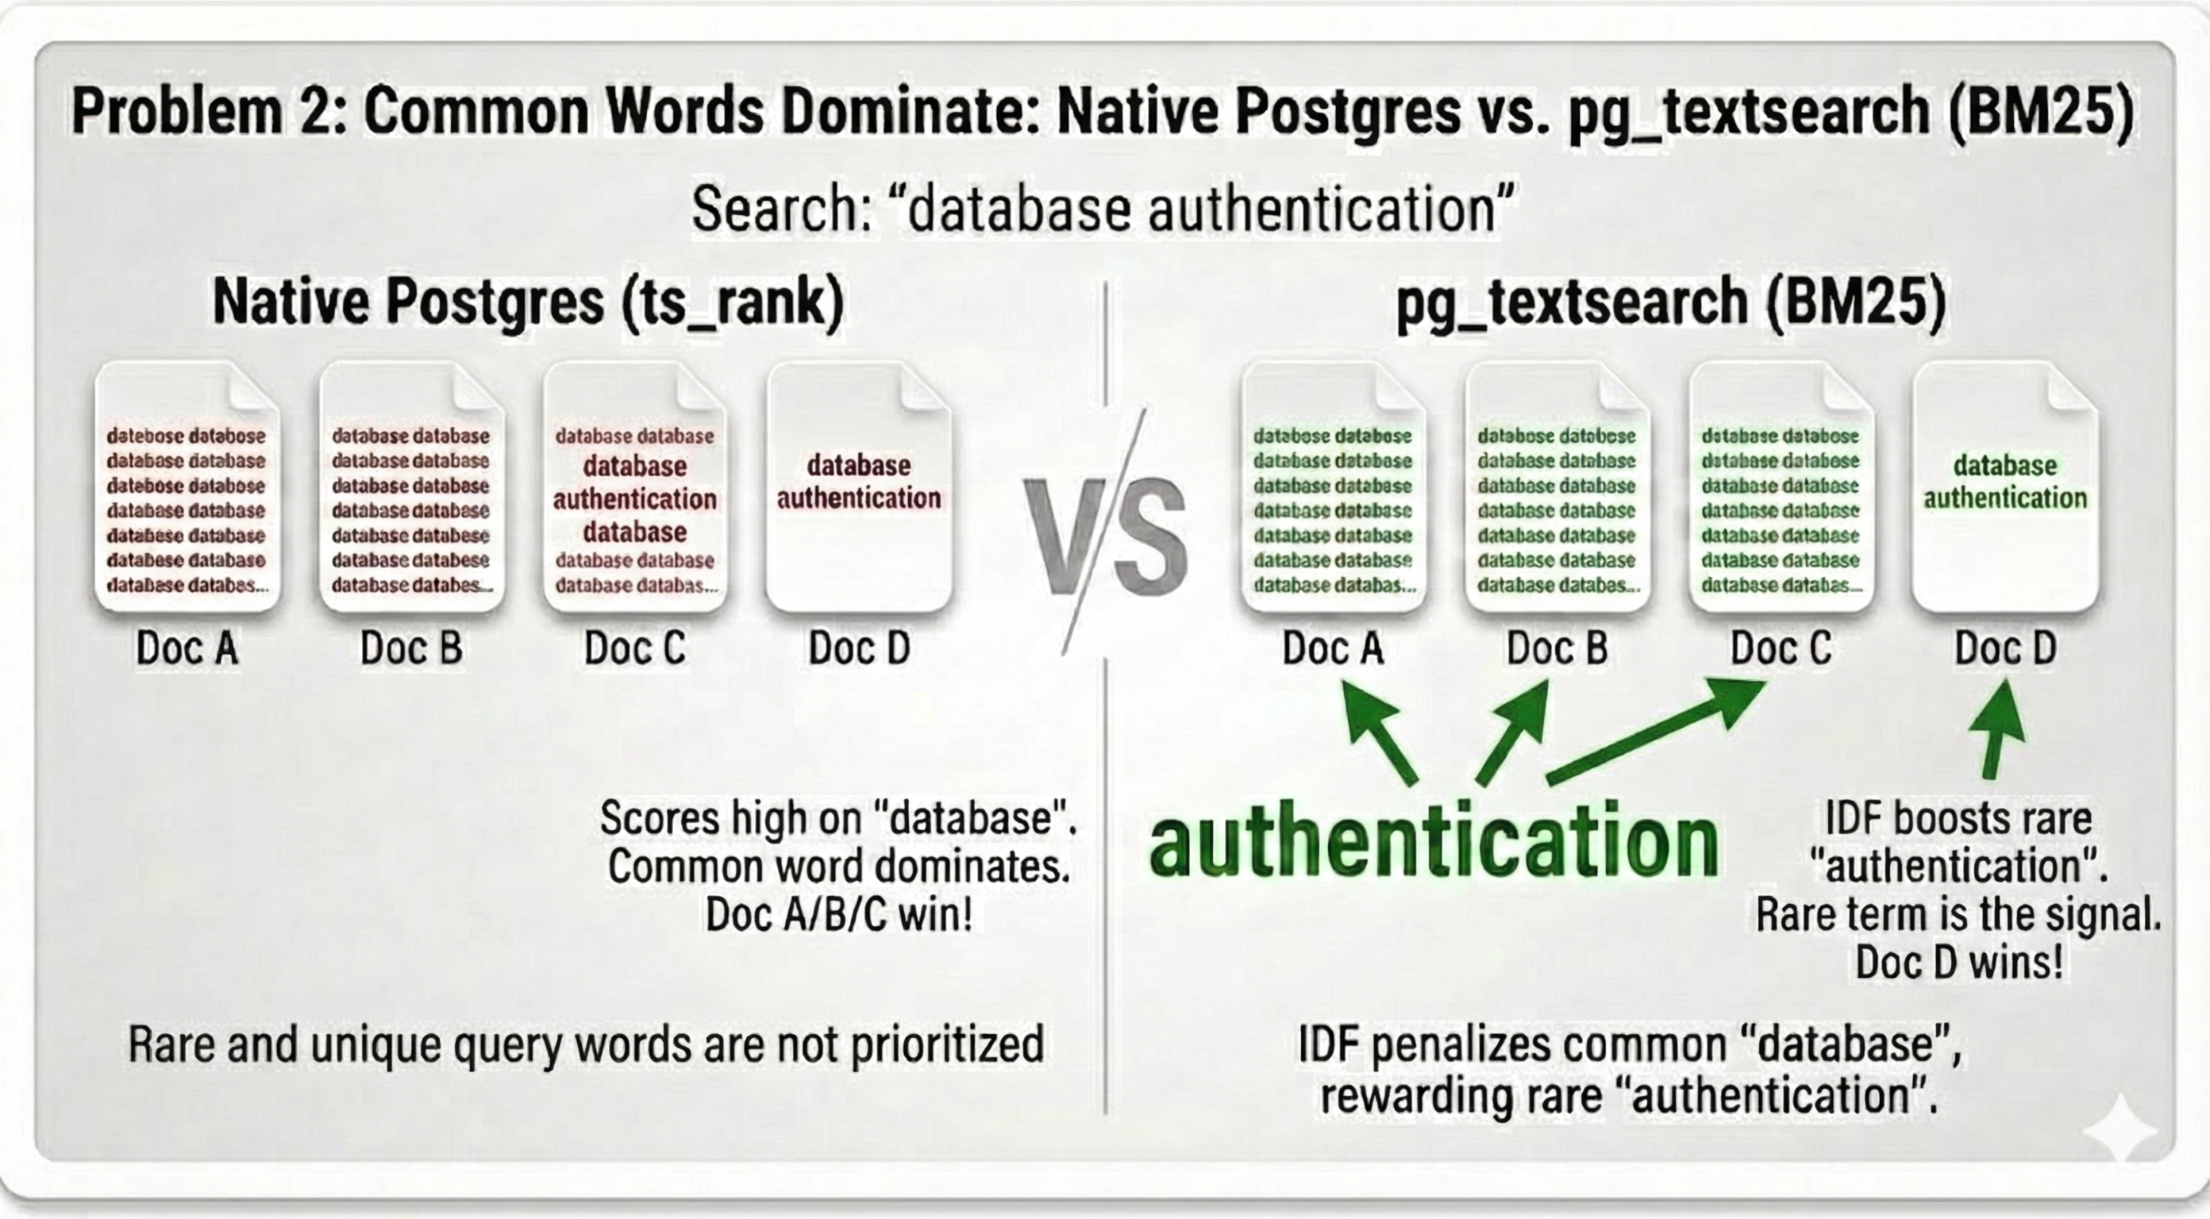

Problem 2: Common Words Dominate

### Problem 3: Long Docs Always Win

**Search:** EXPLAIN ANALYZE

| Native Postgres | BM25 |
| --- | --- |
| #1: Complete Tuning Guide (8 mentions) | #1: Quick EXPLAIN Tip |
| #2: Quick EXPLAIN Tip (2 mentions) | #2: Complete Tuning Guide |

The long guide has more keyword matches, so native ranks it higher. But the short tip is *entirely* about EXPLAIN ANALYZE. It’s a better result. BM25 uses **length normalization** to fix this.

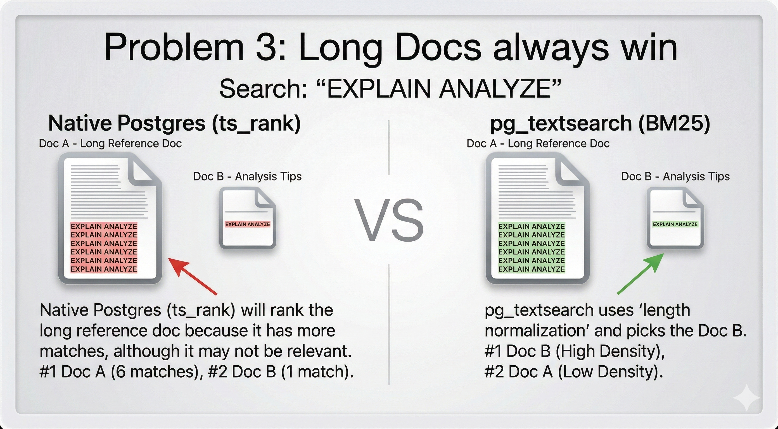

Problem 3: Long Docs Always Win

### Problem 4: All-or-Nothing Matching

**Search:** database connection pooling

Native Postgres uses Boolean AND by default (plainto_tsquery). Only docs with ALL three terms match. Result: 2 documents.

You could switch to OR (to_tsquery with |). Now you get 13 results. But: - Rankings become flat (many docs score identical 0.02) - Spam still ranks in the middle - Hard to tell relevant from irrelevant

BM25 does **ranked retrieval** properly. Every doc gets a meaningful score based on how well it matches. Docs with 2 of 3 terms rank lower than docs with all 3, but they still appear with differentiated scores.

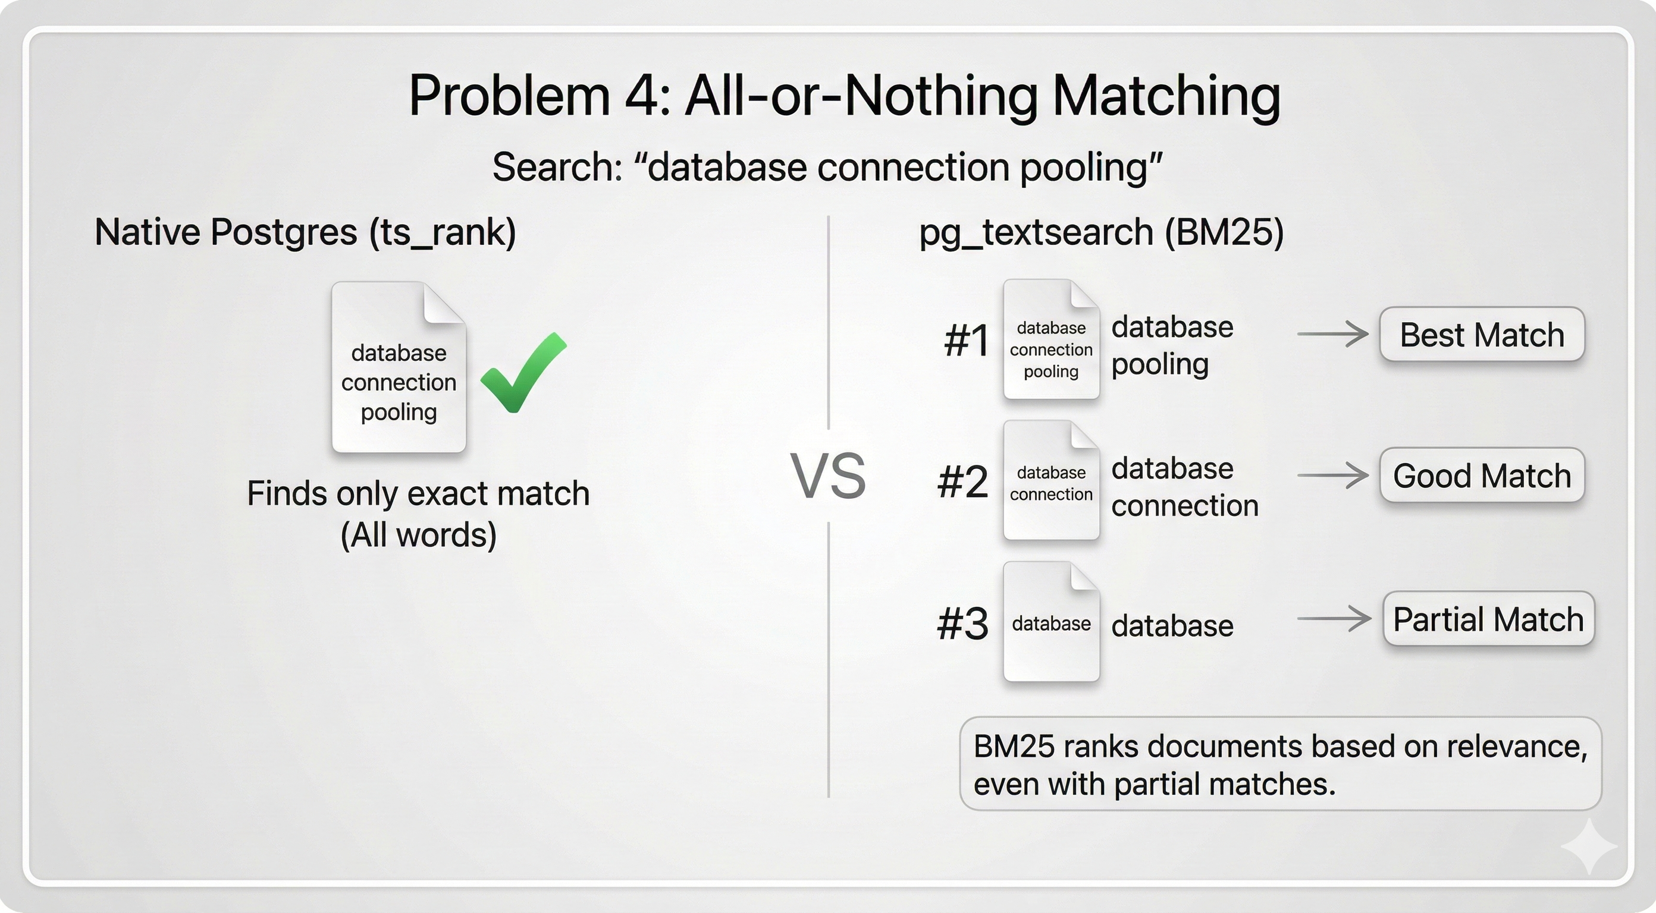

Problem 4: All-or-Nothing Matching

## What About Semantic Search (for AI Agents)?

BM25 handles keywords. For meaning, you need vectors.

Here’s the thing: **the best AI retrieval systems use both.** Pure vector search misses exact matches. Pure keyword search misses synonyms. Hybrid search wins.

This is why LangChain’s EnsembleRetriever combines BM25 + vectors. Why Cohere recommends BM25 first-stage retrieval before reranking. Why Anthropic and OpenAI use hybrid retrieval in their RAG pipelines.

Good news: Postgres does hybrid too. With [pgvector](https://github.com/pgvector/pgvector) and [pgvectorscale](https://github.com/timescale/pgvectorscale), you can run BM25 + vectors in one query:

-- Hybrid search with Reciprocal Rank Fusion (same technique used by Cohere, Pinecone)  
WITH bm25 AS (  
 SELECT id, ROW_NUMBER() OVER (ORDER BY content <@> to_bm25query($1)) as rank  
 FROM docs LIMIT 20  
),  
vector AS (  
 SELECT id, ROW_NUMBER() OVER (ORDER BY embedding <=> $2) as rank   
 FROM docs LIMIT 20  
)  
SELECT id, 1.0/(60+bm25.rank) + 1.0/(60+vector.rank) as score  
FROM bm25 FULL JOIN vector USING (id)  
ORDER BY score DESC LIMIT 10;

Both signals. One database. No external services.

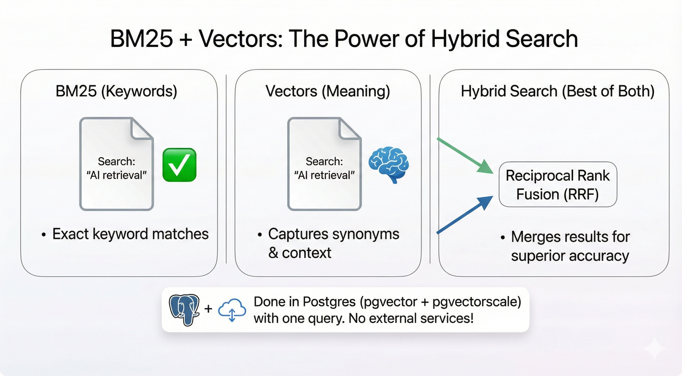

Hybrid Search

## See It For Yourself

We built a demo that runs all four search methods side-by-side: Native Postgres, BM25, Vector, and Hybrid. Same query, same documents, different results. You’ll see exactly why BM25 wins.

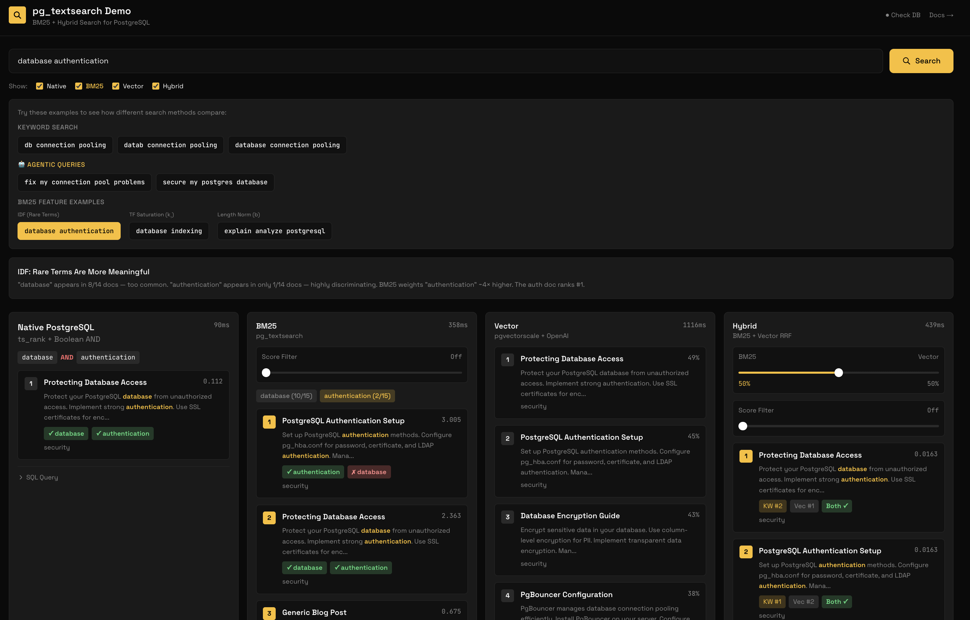

Demo App

Type a query. Watch Native Postgres fail on partial matches while BM25 finds what you need. See how Vector search understands meaning. Watch Hybrid combine both for the best results. No hand-waving. Just run queries and compare.

**Clone it:**

git clone https://github.com/rajaraodv/pg_textsearch_demo.git  
cd pg_textsearch_demo  
npm install  
# Add DATABASE_URL and OPENAI_API_KEY to .env.local  
npm run setup && npm run dev

**Or just use pg_textsearch directly:**

CREATE EXTENSION pg_textsearch;  
CREATE INDEX docs_idx ON documents USING bm25(content) WITH (text_config='english');  
  
SELECT title, content <@> to_bm25query('your search') as score  
FROM documents  
ORDER BY score  
LIMIT 10;

## The Point

You don’t need Elasticsearch. You don’t need Algolia. You don’t need another service to sync, monitor, and pay for.

You need [pg_textsearch](https://github.com/timescale/pg_textsearch).

It’s fully open source under the [PostgreSQL license](https://opensource.org/licenses/PostgreSQL), the same highly permissive license as Postgres itself. Use it anywhere, for anything, no strings attached.

Already available on [Tiger Data](https://console.cloud.timescale.com).

**Just use Postgres.**

## Learn More

* [pg_textsearch GitHub](https://github.com/timescale/pg_textsearch) - Source code and examples
* [pg_textsearch Documentation](https://www.tigerdata.com/docs/use-timescale/latest/extensions/pg-textsearch) - Full reference
* [Introducing pg_textsearch](https://www.tigerdata.com/blog/introducing-pg_textsearch-true-bm25-ranking-hybrid-retrieval-postgres) - Deep dive blog post
* [BM25 Algorithm (Wikipedia)](https://en.wikipedia.org/wiki/Okapi_BM25) - How the ranking math works